TITLE: Title: To visualize temporal data and analyze trends

Objective:

To visually represent temporal data in order to identify patterns, trends, and changes over time._________________________________________________________________________

Expected OUTCOME of Experiment: CO 2

Detect and understand the stories within datasets and its applications.
________________________________________________________
Books/ Journals/ Websites referred:

- Data Analysis with Microsoft Excel, Wayne L. Winston, Microsoft Press.
- Excel 2019 Bible, John Walkenbach, Wiley.
- Practical Statistics for Data Scientists, Peter Bruce and Andrew Bruce, O’Reilly Media
_____________________________________________________________________
Background Theory:
This experiment focuses on the visualization of temporal data to facilitate effective analysis of patterns and trends over time. Temporal data, which is indexed by time, is commonly encountered in domains such as data analytics, economics, weather forecasting, and system monitoring. By representing such data using appropriate visualization techniques like line charts, time-series plots, and trend lines, complex variations and long-term behaviors become easier to interpret. Visual analysis helps in identifying seasonal effects, growth or decline trends, anomalies, and cyclic patterns, thereby supporting informed decision-making and predictive analysis.

Dataset link: Airline passenger dataset https://raw.githubusercontent.com/jbrownlee/Datasets/master/airline-passengers.csv
Task to be performed on the given dataset
- Connect to the Data Source and Visualize Time-Series Data
Connect to the dataset using Python (Pandas) and visualize monthly airline passenger data using a Matplotlib line chart with time on the X-axis.
- Create and Refine the Time Series View
Create a clear visualization by adding axis labels, titles, markers, grid lines, and legends to make the time-series plot readable.
- Focus on Trend Analysis
Apply a moving average using Pandas to smooth short-term fluctuations and highlight the long-term trend in the data.
- Compute moving average
- Explore Temporal Patterns and Seasonality
Examine recurring monthly and yearly patterns to identify seasonal variations in passenger traffic.
- Compute yearly totals / averages
- Identify month with maximum and minimum passengers
- Plot average passengers by month
- Compare first 5 years vs last 5 years Compute percentage growth year-on-year
- Drill Down into Time-Based Details
- Drill Down by Month Across Years
- Line Plot for Only High-Traffic Months
16010123012_AaryanSharma

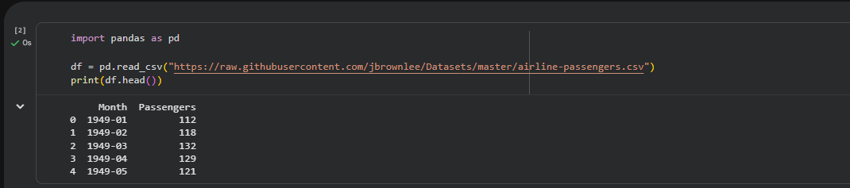
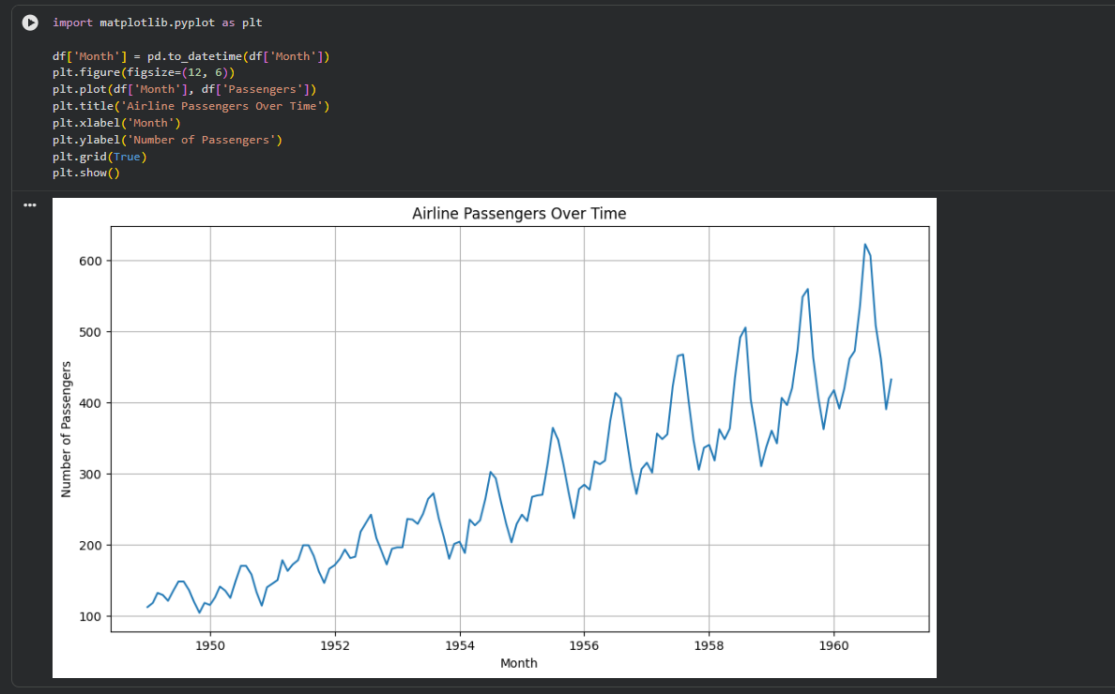
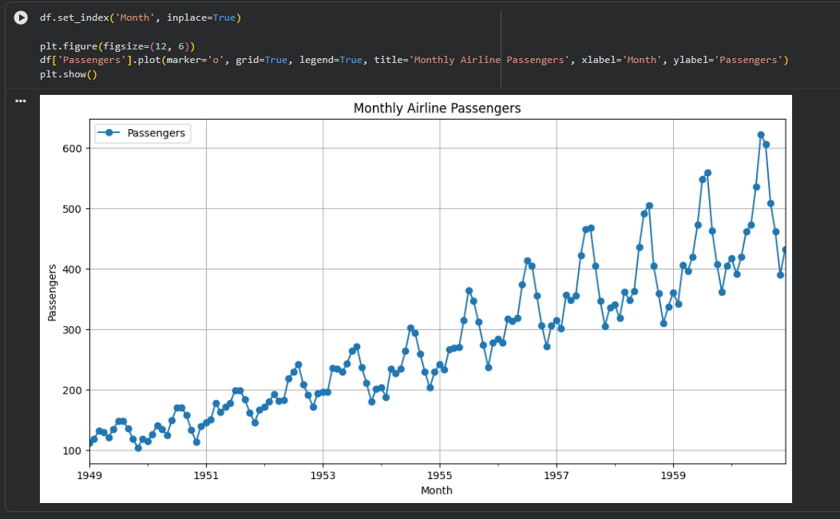
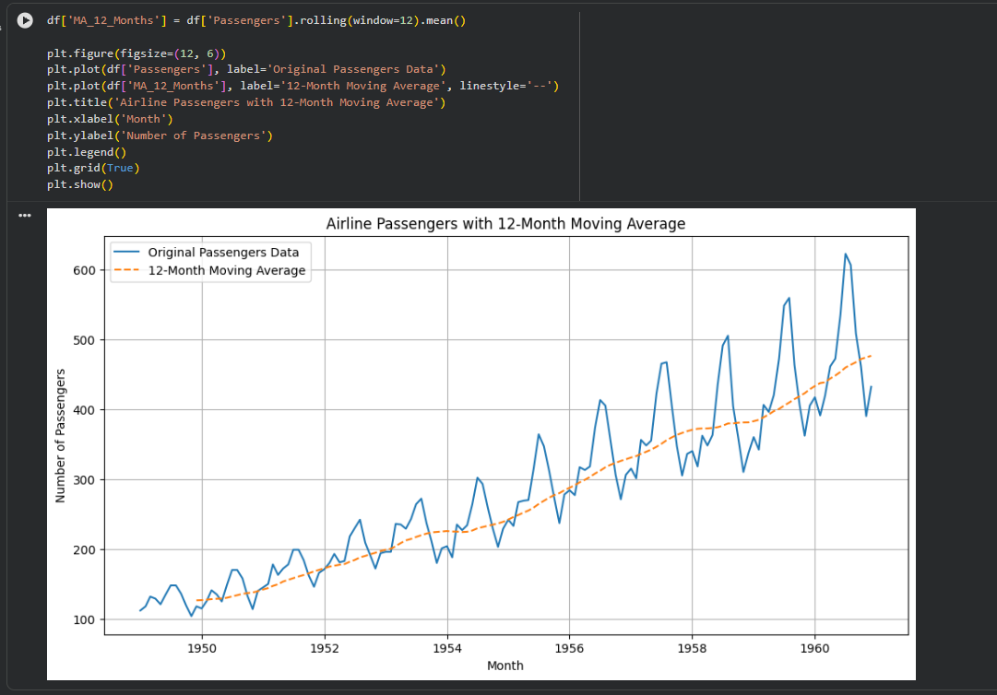
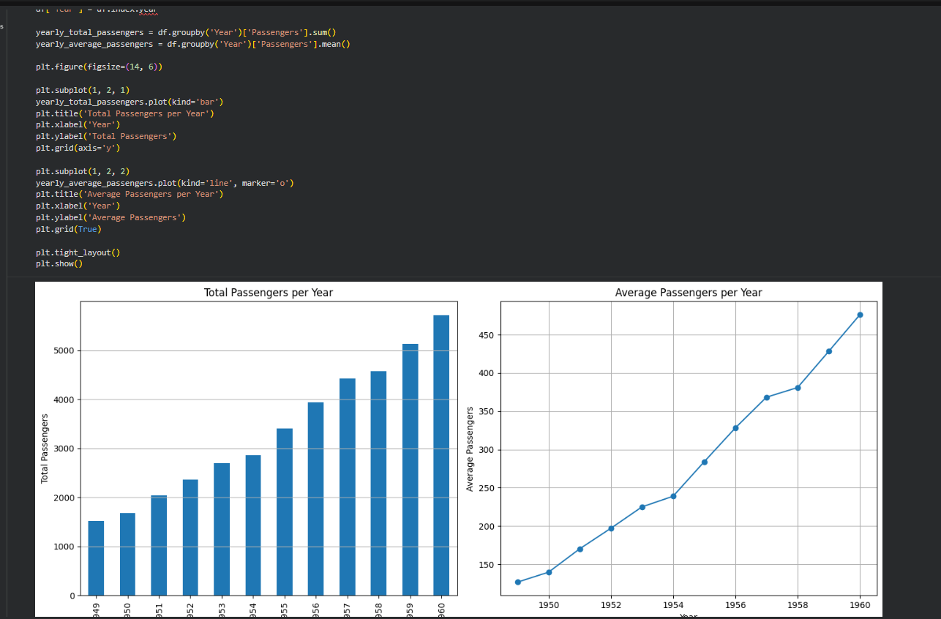
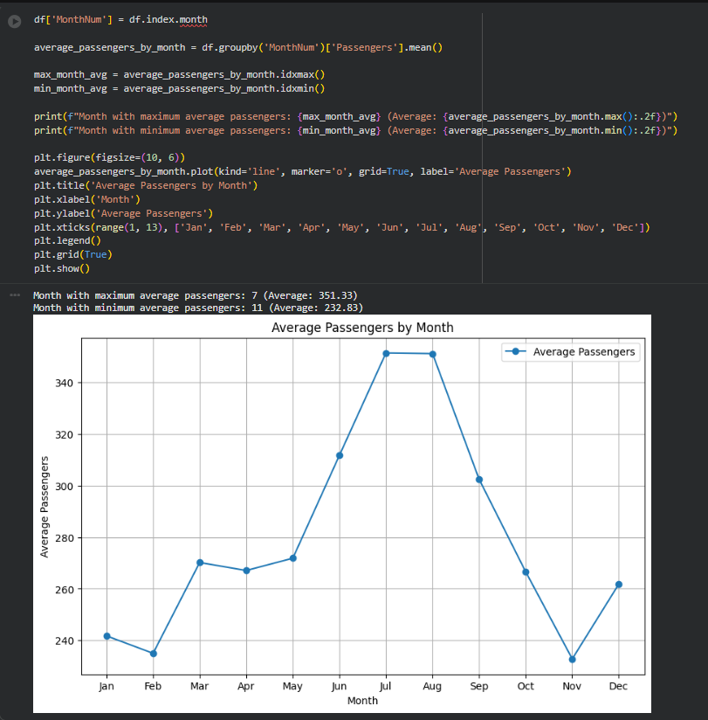
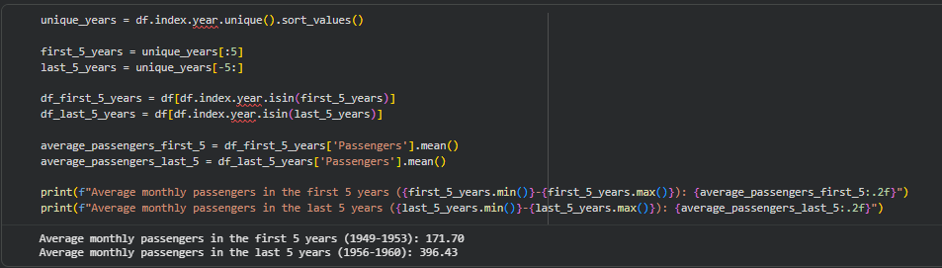
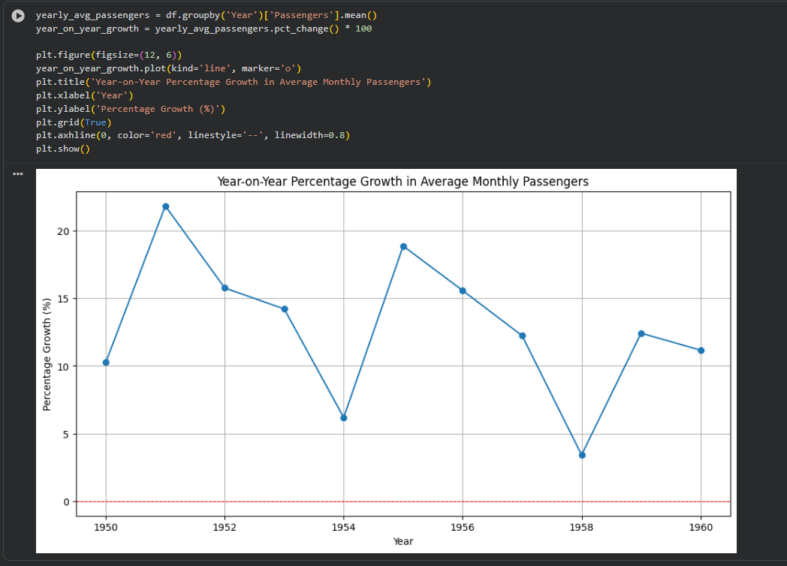
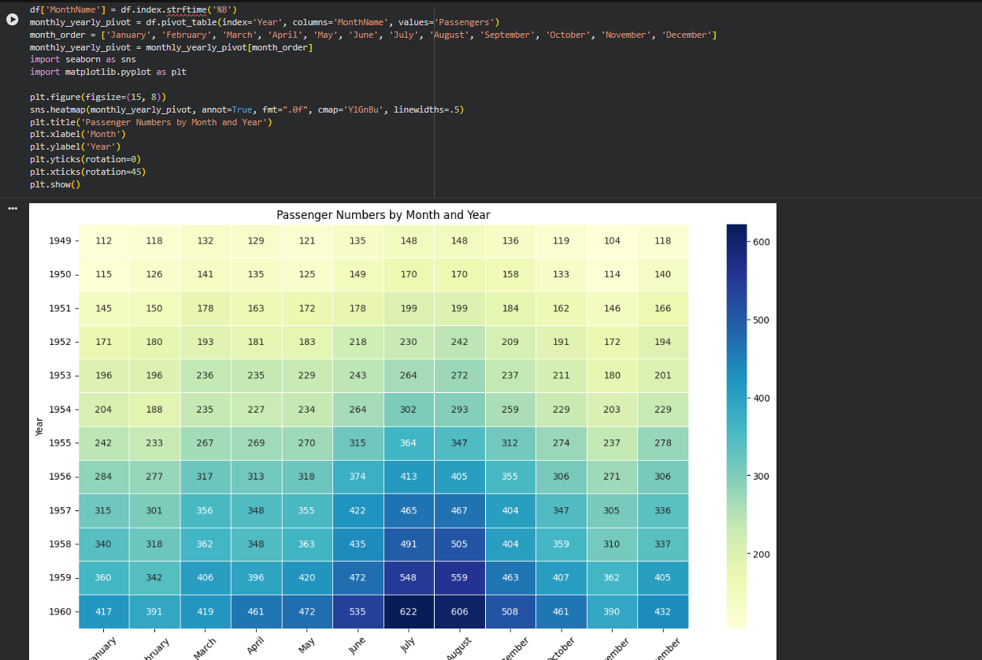
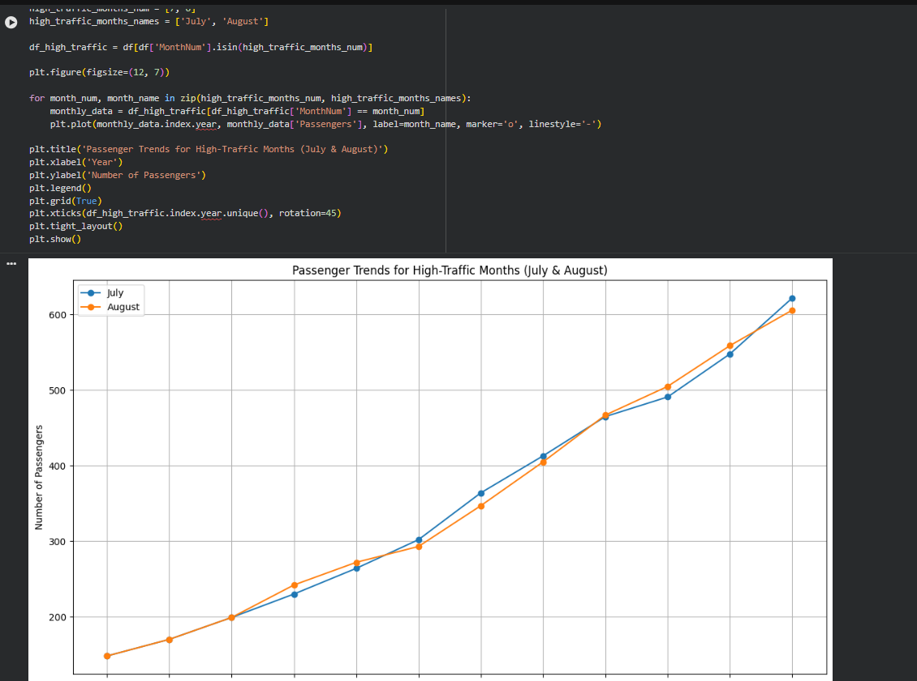

Post Laboratory Questions:
Following questions are to be handwritten and attach the photograph of the answer in this document.
      - How do moving averages help in identifying trends?
Moving averages help in identifying trends by smoothing out short-term fluctuations and random noise in time-series data. By calculating the average of data points over a fixed window of time, moving averages make long-term upward or downward patterns more visible. This allows analysts to focus on the overall direction of the data rather than reacting to temporary spikes or drops. As a result, moving averages are commonly used to understand growth, decline, or stability in trends over time.
      - How can you detect anomalies in a time-series dataset?
Anomalies in a time-series dataset can be detected by identifying data points that significantly deviate from normal behavior or expected patterns. Common methods include visual inspection using line plots, statistical techniques such as z-scores, and comparison against moving averages or confidence intervals. Sudden spikes, drops, or irregular patterns that do not follow historical trends or seasonality are typically considered anomalies. Detecting these anomalies helps in identifying errors, unusual events, or unexpected changes in the system.
      - How do you analyze seasonal patterns using Python?
Seasonal patterns in time-series data can be analyzed using Python by decomposing the data into trend, seasonality, and residual components. Libraries such as pandas and statsmodels provide functions like seasonal decomposition that separate repeating patterns from long-term trends. Visualizing the data using line plots, monthly averages, or seasonal subplots also helps in identifying regular cycles. This analysis makes it easier to understand how data behaves during specific periods such as months or quarters.
      - Explain how drilling down into specific months or years helps in understanding the data.
Drilling down into specific months or years allows for more detailed analysis of time-series data by narrowing the focus to smaller time intervals. This helps in identifying short-term patterns, seasonal effects, or irregularities that may not be visible in aggregated yearly data. By examining data at finer granularity, analysts can compare performance across different periods, detect peak or low activity months, and understand the causes behind variations. This approach leads to more accurate insights and better decision-making.
      - What patterns can you observe in the airline passenger dataset from 1949–1960?
From the analysis of the airline passenger dataset (1949-1960), we can observe several key patterns:
- Strong Upward Trend: There is a clear and robust increasing trend in the number of airline passengers over the entire period, as highlighted by the 12-month moving average and increasing yearly totals/averages.
- Pronounced Annual Seasonality: The dataset exhibits strong annual seasonal patterns. Passenger numbers consistently peak during the summer months (July and August) and reach their lowest points during the late autumn/early winter months (e.g., November, February).
- Consistent High-Traffic Months: July and August consistently register the highest average passenger numbers each year, and their passenger counts show a steady increase over the years, indicating their consistent status as peak travel months.
- Significant Growth Over Time: The average monthly passengers significantly increased from the first 5 years (1949-1953) to the last 5 years (1956-1960), demonstrating substantial growth in air travel during this decade.
- Fluctuating Growth Rate: While overall growth is positive, the year-on-year percentage growth in average monthly passengers shows fluctuations, meaning the rate of increase wasn't constant throughout the period.

